

Fine Arts Club

AEXC110N - Basic Art and Craft Techniques

Dheetchanya Mohan - 23BAI1397

SUMMARY OF CONTRIBUTIONS

**Academic Year 2024-25**

May 2025

**List of Events Participated/Contributed**

1. Volunteered for Vibrance Ambience work (worked 3-4 hours per day for a week)

* Worked on Barbie Photobooth, Photobooth with butterflies & flowers, painting work, any other tasks I was assigned, etc.

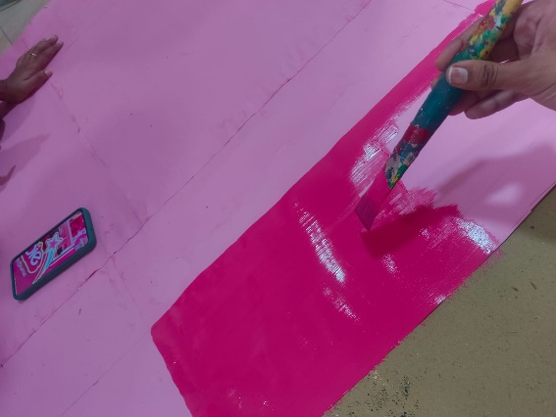 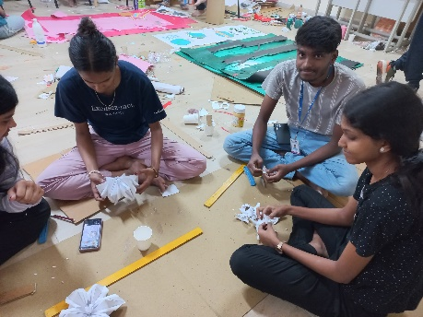 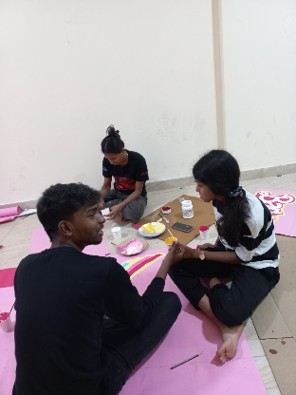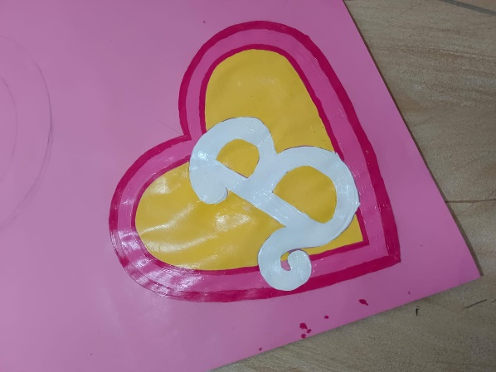 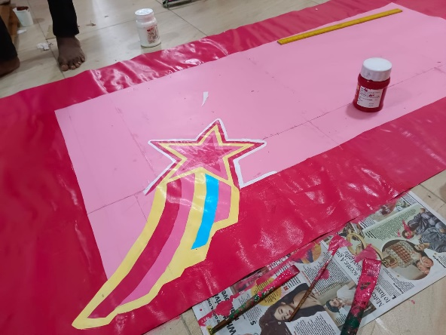 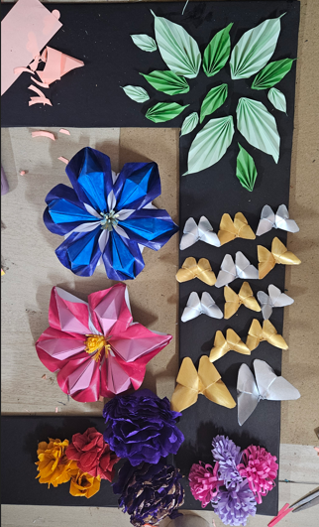 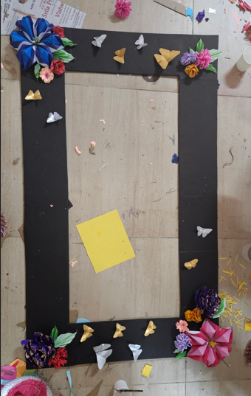 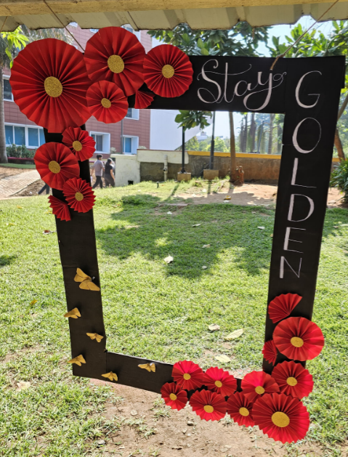

2. Participated in Art for Azadi Event. Made an art work of Yaali which is related to one of five topics provided for the event - Topic: Mythological Stories. Submitted softcopy and hardcopy of artwork.

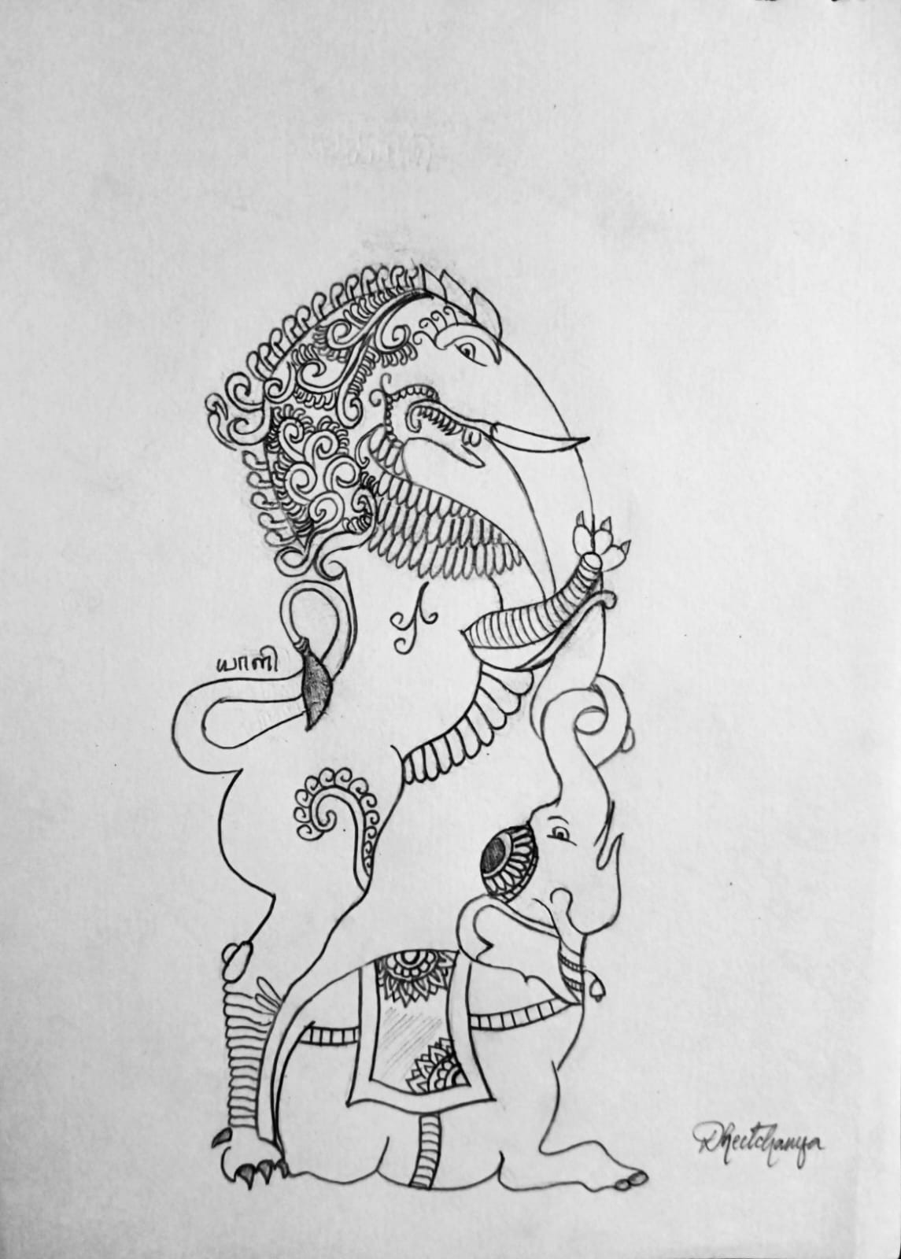

3. Volunteered for Vibrance Club Expo craft works. Drew and painted multiple decorations, helped with crafts as requested by club heads. (2 hours)

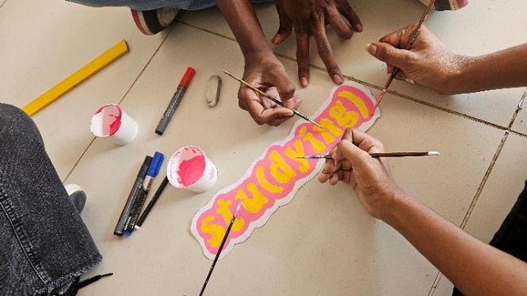

4. Did marketing in front of AB1 for Art Carnival & Painting Competition events. Showed posters and explained about the events to students and made them sign up and/or share with their friends (3 hours)

5. Purchased Club T-shirt.

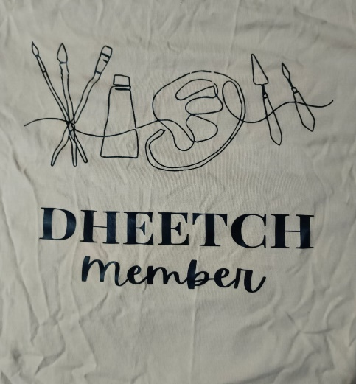

6. Volunteered for Pitch-a-thon event decoration work and helped with balloon decorations (2 hours)

7. Registered and paid for Art Carnival event. Participated in event and also got a tattoo painted.

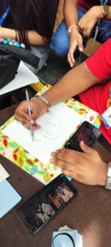 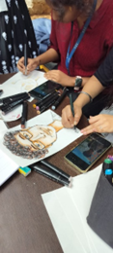 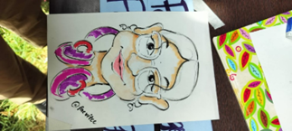

8. Did marketing for Art Carnival event around Clock Court and Gazebo while the event was taking place in order to bring more engagement to the event (1.5 hours)